CONTENTS

- Policy Statement
- Food Safety Procedures
- Related Guidelines, Standards, Frameworks and Other Sources

1. POLICY STATEMENT

The centre prides itself on adhering to safe food handling and storage practices to prevent the contamination of food. It implements good personal hygiene, correct food handling and storage and effective cleaning and pest control practices.

The NSW Food Authority encourages businesses to implement the practices outlined in the Children’s Services Voluntary Food Safety Program (FSP) to ensure that safe food is prepared and served. The FSP template conforms to national Standard 3.3.1 of the Food Standards Code.

This policy is based on the procedures set out in the Children’s Services Voluntary Food Safety Program (FSP).

2. Food Safety Procedures

2.1 Purchase and transport

- Purchase food only from a reputable, trusted supplier or retail outlet that you are confident will provide safe and suitable food.
- Select and purchase foods that are in good condition in order to minimise chemicals, bacteria or pests getting into food. For example, check that:
- packaged foods (eg eggs, meat, food in packets, cans, cartons) are clean, intact and undamaged
- fresh produce (eg fruit and vegetables) is clean, fresh and undamaged

- Select and purchase refrigerated foods that are 5°C or below, hot foods that are 60°C or above, and frozen foods that are hard frozen, to minimise the growth of bacteria.
- Check food is within its ‘use-by’ date.
- Transport refrigerated and frozen foods in an esky or cooler bag with ice bricks, and hot foods in an insulated container (eg foam box) to minimise the growth of bacteria.
- Go straight from the storage to the facility kitchen to minimise the time that foods are out of temperatures control.

2.2 Approved suppliers list

- A children’s services business should keep records of the name and address of the vendor, manufacturer, packer or importer of all food received on the premises. Food received by the business should only be purchased from approved suppliers.
- Before being approved as a supplier, make sure the supplier understands that you expect food delivered to comply with the national Food Safety Standards.
- The supplier should agree to your delivery requirements such as:
- All foods: Within ‘use-by’ or ‘best before’ date. Correctly labeled with manufacturer’s name and address
- Cold foods: Must be received at 5ºC or below (eg raw and cooked meats, dairy foods)
- Hot foods: Must be received at 60ºC or above (eg pre-cooked meals from a supplier)
- Frozen foods: Must be received hard frozen (eg ice cream,frozen fish)
- Dry goods: Packaging undamaged and clean. Cans that are dented, rusted or blown should not be used.
- You should keep a list of your approved food suppliers so you can be confident who will supply your business with safe food.
- Record the supplier’s business name, contact person and contact phone number. Also the type of products supplied (eg meat, fruit and vegetables, dairy, dry goods). Add any relevant notes or special instructions and record the date they were approved as a supplier.

  - Personal hygiene

It is important for all staff that handle food to follow good personal health and hygiene
practices so as not to compromise the safety and suitability of food.

Food handlers (eg cooks and eudcators) should be trained in the following practices and the
Nominated Supervisor should regularly check they are observed:

Hand washing
- Food handlers should wash their hands before preparing or handling food and after using the toilet, changing nappies, smoking, coughing, sneezing, using a handkerchief or tissue, eating or drinking.
- When washing their hands, food handlers should use the hand washing facilities provided, use soap and warm running water and thoroughly dry their hands on a single use towel.

Clothing
- Food handlers should wear clean outer clothing when preparing food.
- An apron that is easily cleaned or disposable over their clothes is recommended, especially when working with raw meat, poultry or eggs. Food handlers should remove aprons when performing any other duty that does not involve food.
- Wear gloves, however, the use of gloves should not replace hand washing between activities. When gloves are used, keep them clean and intact and change them whenever they might have become contaminated.

Hair
- Food handlers should tie back or cover their hair when preparing food to prevent it from falling into food.

Personal effects
- When preparing food, food handlers should not wear watches or loose jewellery,
especially on hands and wrists (except a plain wedding band).
- Food handlers should keep fingernails short and clean and not wear artificial fingernails.
- Personal belongings (eg handbags, mobile phones, outdoor coats) that are not needed for food handling should be stored in allocated storage areas.
- Food handlers should not eat, sneeze, blow or cough over unprotected food or surfaces likely to come into contact with food.

Injury
- Cuts and sores on exposed body parts (eg hands) should be covered with a bandage (eg bandaid) that is completely covered with a waterproof covering (eg glove) when preparing food.
- Blue or coloured Band-Aids are available for food handlers, if accidents occur that require covering the wound.

Illness
- Food handlers should not prepare food if they have diarrhoea, are vomiting, or have other symptoms of illness (eg fever, sore throat with fever, nausea, jaundice, abdominal cramps).
- Staff members should advise the Nominated Supervisor if they have these symptoms.

  - Storage

Dry storage (pantry)
- Store all food off floor in a clean and tidy area. This will discourage pests and insects from breeding and spreading harmful bacteria to food.
- Keep foods covered or sealed in clean containers to prevent foreign objects,
pests and harmful bacteria entering the food.
- Food must be stored separately from chemicals (eg cleaning and pest
control) to prevent them from contaminating food. Throw away any food exposed to
chemicals.
- Rotate food stocks (First In First Out) so you are not left with old stock. Foods with ‘use-by’ dates have a limited shelf life.
- Throw away any old, damaged or unlabeled stock, and food past its ‘use-by’ date.
- If storage areas are dirty, do an extra clean.
- If pest activity sighted, advise the Nominated Supervisor and contact pest controller.

Cold storage (fridge)
- Chilled food must be stored at 5°C or below (eg milk and cream; most foods with a ‘use-by’ date; food with ‘keep refrigerated’ on the label; cooked food to be served the next day; ready-to-eat food such as salads and desserts)
- Store raw foods (eg meat) below cooked and ready-to-eat foods, on the bottom shelf of the fridge. This prevents harmful bacteria in juices from raw food from dripping onto other cooked or ready-to-eat food and contaminating it.
- Label any opened packaged/canned food that is opened and then stored in the fridge with the date opened and use this to monitor for consumption within the recommendations on the instructions on the packaging.

Frozen storage (freezer)
- Frozen food must be stored so they stay hard frozen (eg minus 10°C or below)

Testing
- Place a thermometer or temperature gauge inside each fridge. At the start of each day, check and record the temperature. Check food in each freezer is hard frozen.

2.5 Preparation

How to prepare food safely
- Have separate preparation areas for raw foods (eg raw meat, chicken, fish and eggs) and cooked (eg quiches, pie, lasagne, pizza) or ready-to-eat foods (eg sandwiches, salads, fruit platters). This helps prevent the spread of harmful bacteria. If raw food comes into contact with cooked or ready-to-eat food, throw the cooked or ready-to-eat food away.
- Thoroughly wash hands with warm running water and soap prior to food preparation and when hands become contaminated.
- Dry hands well with paper towel and where possible minimise hand contact with ready-to-eat foods using disposable gloves or utensils such as tongs, serving spoons and egg lifters. Ready-to-eat foods are foods that are minimally processed and eaten without further cooking, such as chopped fruit, salads, sandwiches and cakes.
- Thoroughly clean and sanitise chopping boards and knives between uses and use colour coded chopping boards to help prevent cross contamination. Harmful bacteria can easily spread from dirty equipment, utensils and surfaces to food, making it unsafe. If any food becomes contaminated from dirty surfaces, equipment, utensils or unwashed hands, throw it away.
- Wash fruit, vegetables and salad ingredients thoroughly in clean drinking-quality water before preparing and serving. Peel, trim or remove the outer parts as appropriate.
- Washing and peeling will help to remove dirt or chemicals.
- After preparing fresh cut fruit and vegetables, serve immediately, or cover and store on the top shelf of the fridge until serving (on the day of preparation). Once whole fruit and vegetables are cut, they are at greater risk of harmful bacterial growth and need to be handled correctly to keep them safe. Any unused portions should be discarded at the end of the day.
- Particular care should be taken when preparing rough skinned fruit (eg rockmelon and strawberries) which have been linked to foodborne illness outbreaks. It is important to thoroughly wash the skin of these fruits before they are cut, and to observe the 4-hour/ 2-hour rule when preparing and serving these fruits.

  - Cooking

How to cook food safely
- Preheat equipment such as ovens and grills before cooking. Food may not be cooked right through to the centre if you use equipment before it is preheated.
- Cook whole cuts of meat (eg roast beef, roast pork, rolled roasts) until juices run clear
when a skewer is inserted into the middle. Some cuts of meat (eg lamb cutlets, steak)
are still safe if they are slightly pink in the centre, so long as all surfaces are fully
cooked.
- Turn foods during cooking to help it cook more evenly.
- Boil or simmer liquid dishes until they are bubbling rapidly and steaming. Look for these signs so you can be sure the dish is hot enough to destroy harmful bacteria. Records do not need to be kept for these dishes (or when cooking vegetables, stewed fruit, muffins, biscuits etc) as they have a lower food safety risk.
- Stir liquid dishes frequently to make sure food is the same temperature all the way
through with no cold spots.
- Keep cooked foods separate from raw foods to prevent harmful bacteria from spreading to the cooked food and making it unsafe to eat.
- Cook meat dishes (eg meatballs, bolognaise, shepherd’s pie, meatloaf, sausages) all the way through, until they are very hot (steaming) with no pink in the centre.
- Cook chicken dishes (eg drumsticks, roast chicken) so that juices in the thickest part or the largest piece run clear.
- Cook fish (eg fillets, crumbed pieces) all the way through, until the flakes separate easily with a fork.
- Cook eggs until there are no runny whites and the yolk has started to thicken (eg hard boiled, scrambled, fried).
- Cook egg dishes (quiche, pikelets, baked custard) all the way through, until they are firm or set in the middle.
- Hot food should reach a core temperature of 75°C or more during cooking (or 70°C for 2 minutes).

  - Cooling Food

How to cool food safely
- Avoid cooking large quantities of food in advance. Large quantities of food are more
difficult to cool quickly, especially solid food (eg roast beef, lasagne). Slower cooling times increase the risk of harmful bacteria growing.
- Stand cooked food until it stops steaming (eg 20-30 mins) using the methods below, then refrigerate promptly.
- Cool liquid foods more rapidly by stirring occasionally to help release steam.
- A small pot can be rapidly cooled by placing it in a sink with just enough cold water to
come half way up the side. Gentle stirring for 15-30 minutes and refilling the sink as
required with cold water, will bring the temperature down for storage in the fridge.
- Divide food into small portions in clean, shallow containers, ideally around 5cm deep so they cool down quicker.
- Keep food covered during cooling to protect it from contamination.
- Label containers with the name and date it was made, to assist with stock control.
- If food has been contaminated during cooling, throw it away.
- Leave space around food containers cooling in the fridge (do not stack) to allow cold air to flow freely around the food. Fridges should not be overcrowded.
- Cooked food that has been cooled should be stored in a refrigerator for no longer than 48 hours.
- Food intended to be frozen should be rapidly cooled first and then be placed in a freezer within 48 hours of cooling.

  - Reheating

- Preheat equipment such as ovens and grills before reheating. Food may not be heated through to the centre if you use equipment before it is preheated.
- Reheat food to 60 C. within a maximum of 2 hours
- Stir or turn food during reheating to make sure it heats evenly.
- Do not add raw food, or mix in new batches of food, into already reheated food as this
can spread harmful bacteria through the reheated food.
- Always use clean equipment and utensils to handle reheated food.
- Reheat once only. Do not return reheated food to the fridge or freezer. Throw away any leftover reheated food that has not been eaten or served. Reheating and cooling food more than once will increase the risk of bacteria growing as food spends a longer time in the temperature danger zone.

Microwave reheating
- Food purchased from a supplier – follow their reheating instructions.
- Food cooked by the children’s service – stir while reheating until steaming hot in the
centre, and let stand before serving. Frozen product should preferably be thawed prior to reheating to assist uniform heating.

  - Serving (hot & cold)

How to serve food safely
- Serve hot food, reheated food and cold food dishes as quickly as possible to minimise time in the temperature danger zone. Don’t leave them at room temperature for long periods.
- Store cold dishes in the fridge or freezer until serving time, to keep them at the correct
temperature.
- Serving utensils and equipment (including gloves, if used) should be clean so they do not spread bacteria to food. If food becomes contaminated from dirty utensils or poor food handling practices, throw it away.
- Leftover food not served on plates or food not eaten should be thrown away.
- If food has been precooked and chilled, and then served cold (eg quiche, meat for
sandwiches), it should not be stored for more than 48 hours.

  - Cleaning and sanitation

Daily cleaning and sanitation
- Clear and clean work surfaces and equipment as you go, to prevent the spread of bacteria.
- Wipe up spills as soon as they happen.
- Wash work surfaces and equipment thoroughly between tasks to prevent dirt and bacteria spreading onto other foods.
- Remove all solids and scraps from equipment, bench tops and floors, and place into the garbage bin.
- Wash equipment and utensils with hot water and detergent until clean, and rinse with
clean water to remove any residues. Leave equipment to air dry or dry by hand.
- Use dishwashers on the hottest cycle with an appropriate detergent, and clean regularly.
- Wipe clean and sanities bench tops
- Floors are swept and mopped clean with a detergent solution and allowed to air dry.
- Keep bins clean and stored properly so they do not attract pests or cause odours.
- Clean and sanitise aprons, tea towels and reusable cloths.
- Keep toilet and handwashing facilities in a clean and sanitary condition.

Cleaning chemicals
- Cleaning chemicals must be suitable for use with food, and the manufacturer’s instructions must be followed. Ensure that all cleaning chemicals are kept out of reach of children and stored away from food.

Paper towels
- Use single use disposable paper towels where possible, especially for drying hands and wiping up spills on the floor and throw away after each task to minimise bacteria spreading.

Dish cloths
- Replace cloths or sanitise them daily (eg sanitise overnight each day, then replace weekly).
- If cloths are used to wipe surfaces that have had contact with raw meat, they should be cleaned and sanitised with hot water or chemicals or thrown away. Colour coded cloths can also be used for different activities in the kitchen (eg blue for sink, red for benches, green for floor).

Tea towels and oven mitts
- If dishes are dried by hand, use only clean tea towels designated for that specific purpose (ie not also used for mopping up spills or drying hands). If oven mitts are used, clean and sanitise them regularly.

Checking cleaning and sanitation
- At the end of each days food preparation and if required during the day’s operation, the kitchen, the eating area and all food handling equipment must be cleaned and sanitized (where appropriate).
- Food contact surfaces and equipment (eg plates, chopping boards and thermometers) must be cleaned and sanitised. Sanitation can be done using heat and/or chemicals. Items that do not have direct contact with food only need to be cleaned (eg stove, floors and light fittings).
- A daily checklist should be used to check and record the hygiene of the premise and equipment.

2.10. Pest control

Minimise the entry and harbourage of pests to prevent food becoming contaminated. The service should implement the following pest control program and keep records of any pest control undertaken.

- Prevent entrance of pests.
- Fit windows with flyscreens.
- Seal doors with weather strips.
- Check food deliveries thoroughly for signs of pests. Do not accept a delivery if it shows signs of pests (eg gnawed packaging, visible presence).
- Prevent harbourage of pests
- Check your kitchen and storage areas regularly for signs of pests.
- Ensure that the premises are maintained in good repair (ie free of holes, cracks and crevices and access or harbourage for pests).
- Identify locations of all rodent and insect bait stations on the premises.
- Ensure pest control chemicals are suitable for use in food premises, clearly labelled, stored away from food handling areas, and kept out of reach of children.

2.11. Maintenance of premises and equipment

Premises
- The kitchen must be designed, constructed and maintained in a way that minimises the risk of food becoming contaminated.
- Any maintenance issues and construction defects that are identified during routine daily checks and 12-monthly inspections are documented on the appropriate record forms.
- Repair structural damage to your food premises as soon as possible eg damp/chipped plaster, broken tiles, holes in walls or windows.
- Check extractor fans and filters regularly to make sure they are working properly and are free from grease and dirt.

Equipment
- Food handling equipment such as bench tops, chopping boards, knives, utensils, bowls, containers, pots, blenders and anything that is used to handle food must be designed, constructed and maintained in a way that minimises the risk of food becoming contaminated.
- Food preparation equipment such as fridges, freezers, stoves and ovens must be kept clean and in good working order. If servicing of such equipment is required, copies of the reports should be maintained.
- Equipment must be used only for what it was intended and kept clean and in good working order. Throw away any chipped, broken or cracked eating or drinking utensils and repair or replace any equipment or utensils that are damaged or have loose parts.

Checking maintenance of premises and equipment
- A 12-monthly internal audit and maintenance checklist should be used by the cook to check the condition of the premises and equipment.
- If the item on the checklist is satisfactory, write ‘Yes’ next to the item, and if unsatisfactory, write ‘No’ next to the item in the ‘Yes/No’ column. The item should then be repaired or replaced (within a suitable timeframe).
- The action taken to fix the problem, and the timeframe to be repaired (if required), should be recorded in the ‘What you did to fix it’ column on the form.
- All record forms should be signed by the person who completed the record, in the ‘Sign’ column.

2.12. Children’s bottles

- Some of the younger children may have a bottle to help them settle for a sleep in the afternoons. To ensure the wellbeing and safety of those children:
- bottles will only be filled with water or plain milk
- staff will use proper handwashing procedures before handling bottles
- bottles will be clearly labelled and stored in the fridge
- any leftovers in the bottles will be discarded after feeding
- feeding toddlers will be carefully monitored and when the child has finished feeding, the bottle will be removed gently from the child

3.0. RELATED GUIDELINES, STANDARDS, FRAMEWORKS AND OTHER SOURCES
- NSW Food Authority, NSW Government
- Food Standards Australia New Zealand, www.foodstandards.gov.au
- Australian Children’s Education and Care Quality Authority (ACECQA), www.acecqa.gov.au

Policy adopted: 16th June 2014
Policy Reviewed: 1 June 2019
For review: November 2019

Fridge and Freezer Temperature Log
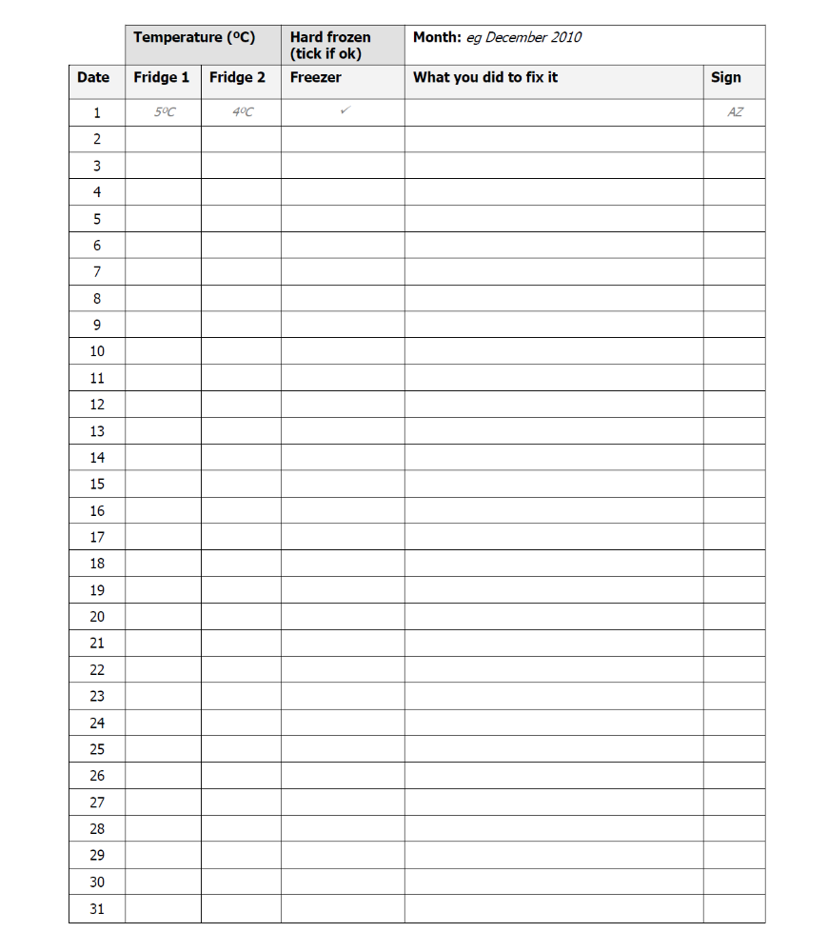

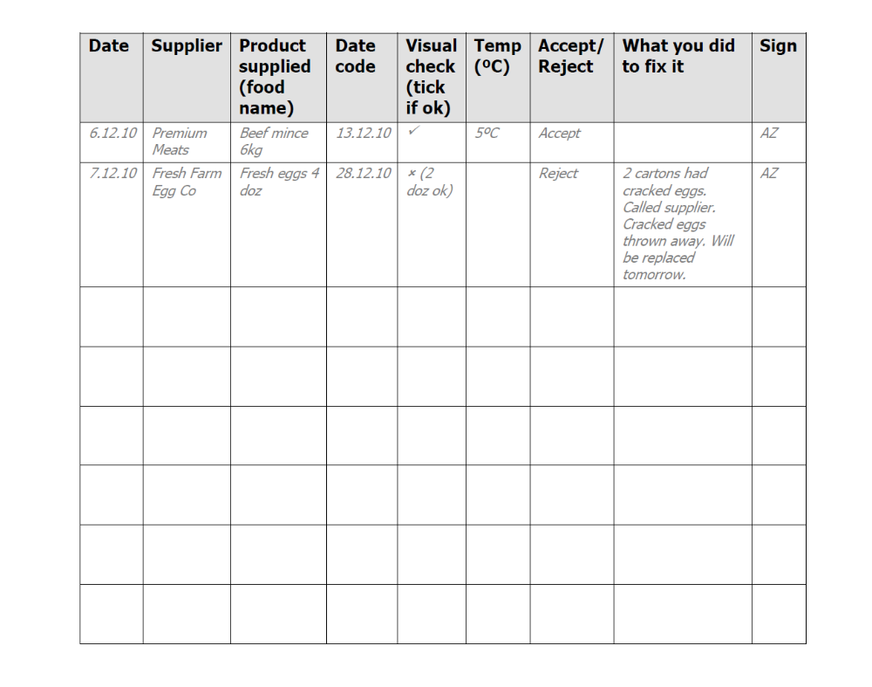
Foods Received Log

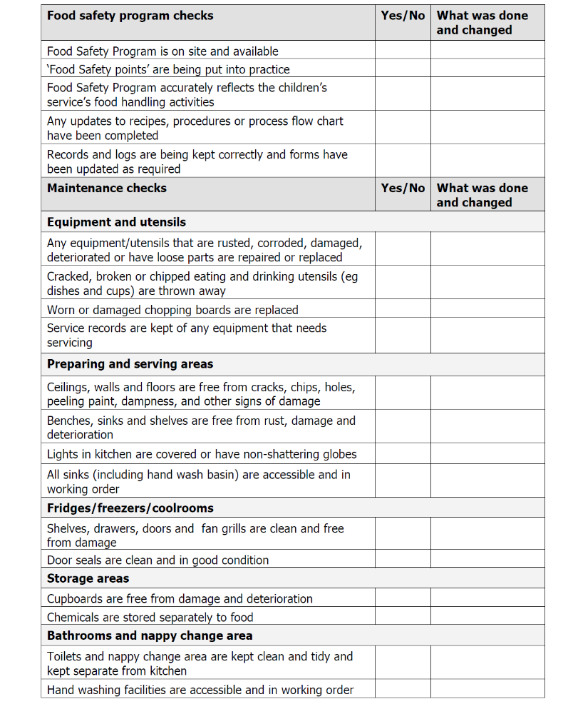

Thermometer Calibration

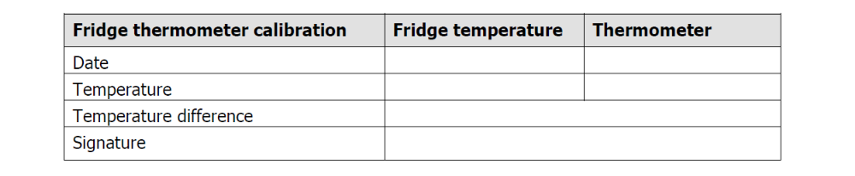

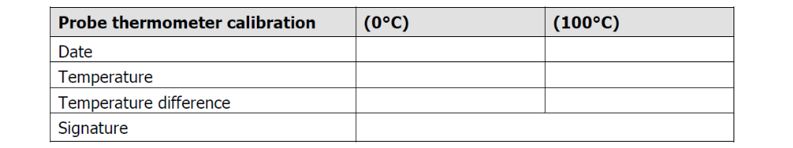

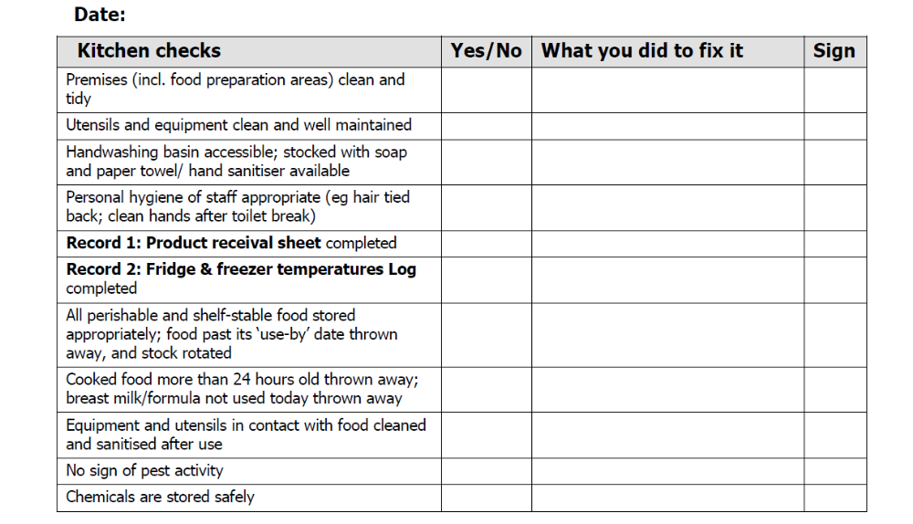

2-hour/ 4-hour cooling rule - from 60°C to 21°C within 2 hours and then from 21°C to 5°C within a further 4 hours

